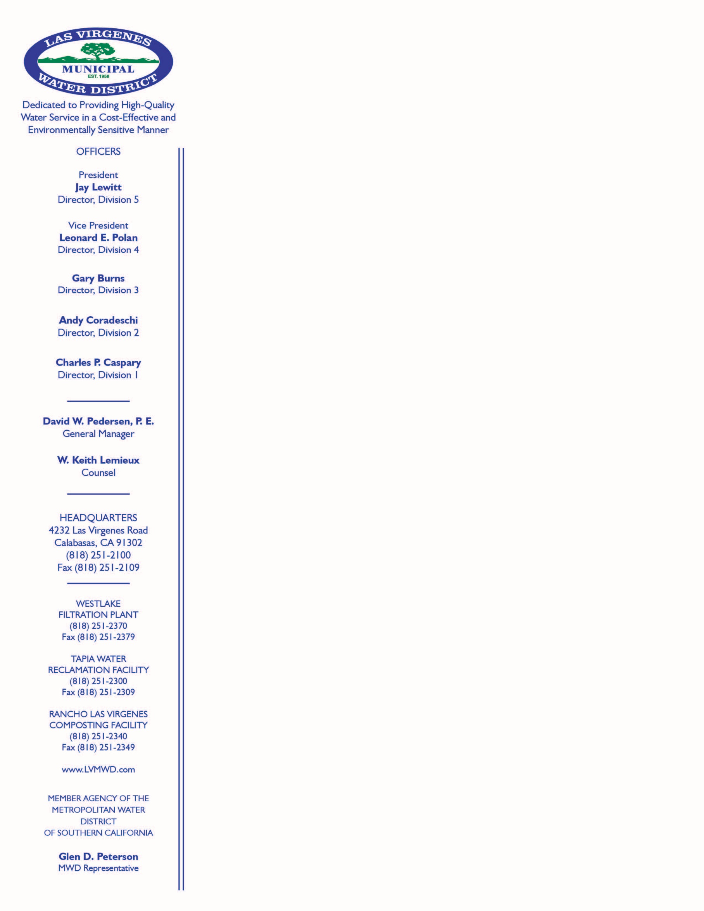 | January 23, 2023  Subject: Time Extension – Resolution for Relief – Woolsey Fire Loss/Rebuild Customers  On December 22, 2022, the Board of Directors of Las Virgenes Municipal Water District (LVMWD) approved Resolution 2615, providing an extension of time to the Resolution for Relief for specific customers impacted by the Woolsey Fire. With this extension, the District is requesting that an application for conditional approval be submitted prior to July 1, 2023 from customers that intend to take advantage of this program (see attached). The application will help the District better understand the number of customers that will be taking advantage of the relief program and the status of rebuilding efforts for individual customers. Formal approval will be granted when the qualifying conditions and criteria for relief can be verified through a separate submittal review process.  What the resolution provides: A substantial credit towards fees when eligible customers are required to upgrade from a ¾" meter to a1" meter to meet updated building codes. The fees for this upgrade would normally cost $10,750 (without a regulator) or $10,996 (with a regulator). With this relief program, most eligible customers will only be required to pay applicable current meter, administration, and installation charges pursuant to Section 3-2.205 of the Las Virgenes Municipal Water District Code at a total cost of $756 (without a regulator) or $1,002 (with a regulator). This cost only applies towards meeting building code upgrades to a 1" meter from a ¾" meter. Quoted rates are effective as of the date of this letter. Additional fees may be required, depending on individual circumstances, and are subject to change pursuant to the capacity fees present when a new meter is installed.  Qualifying Conditions:  - One- or two-family dwellings or townhomes destroyed or rendered uninhabitable; and  - Replacement dwelling is no more than 5% larger, as measured by square footage, and without the addition of accessory units or outbuildings (need building plans to be approved and signed by the Building Department and original square footage from the County Assessor and proposed square footage on signed plans); and  - Customer to provide insurance declaration page showing homeowners coverage for building code upgrades; provide itemized cost of building code upgrades by a licensed contractor; and illustrate insufficient insurance coverage.  - The credit shall be available upon request by an eligible customer through December 31, 2024.  - Relief shall be limited to those customers who owned the affected property at the time of the Woolsey Fire and not extended to customers who have subsequently purchased an affected property.  Note: The fees for any subsequent upgrade to the meter shall be considered with credit provided for a 3/4-inch meter rather than the larger 1-inch meter. Formal requests will be reviewed once a complete submittal packet is provided.  Please apply for conditional approval (form included) no later than July 1, 2023 via mail to:  Las Virgenes Municipal Water District  Attn: Planning Division  4232 Las Virgenes Rd  Calabasas CA 91302  or by email to jbodenhamer@lvmwd.com

