Instructions on putting a web mobile bookmark onto the phone screen

iPhone 1
Android 6

iPhone
1. Open up your Portal site in Mobile Safari browser and log in you may be immediately prompted to save the app to your home screen! | 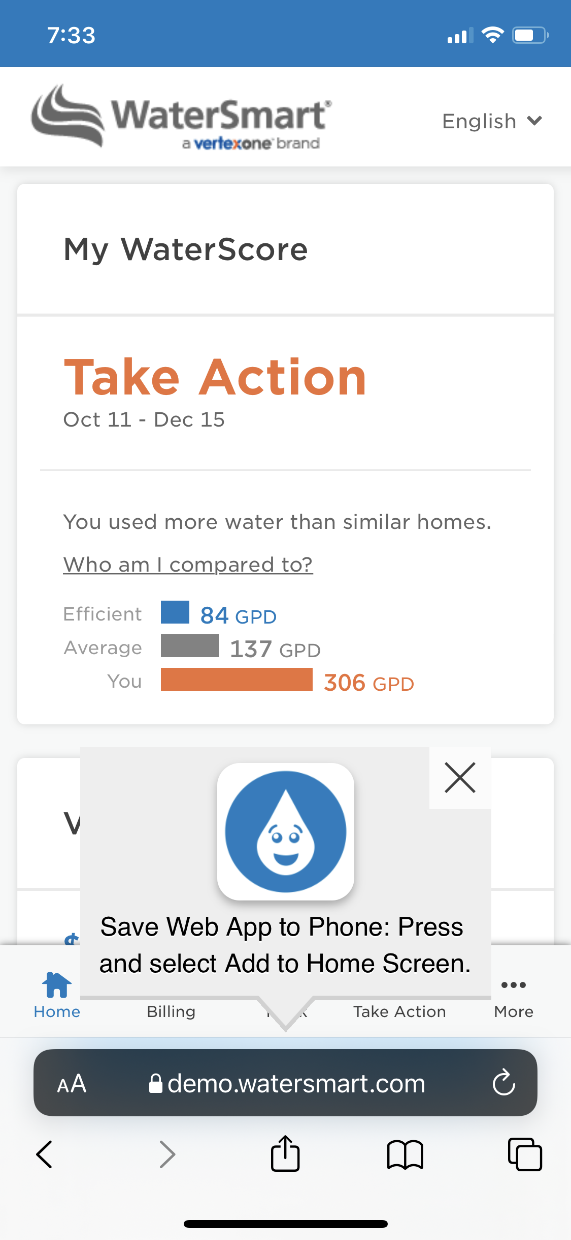
2. Tap the ‘Share’ button at the bottom of the screen (located right in the center, above the home button). | 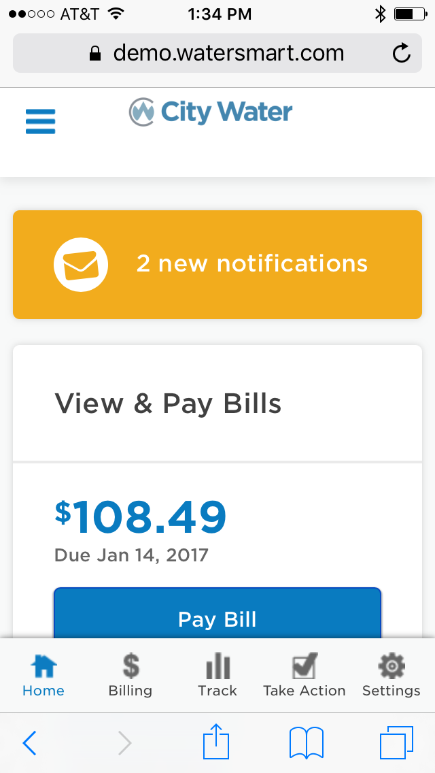
3. Tap “Add to Home Screen” | 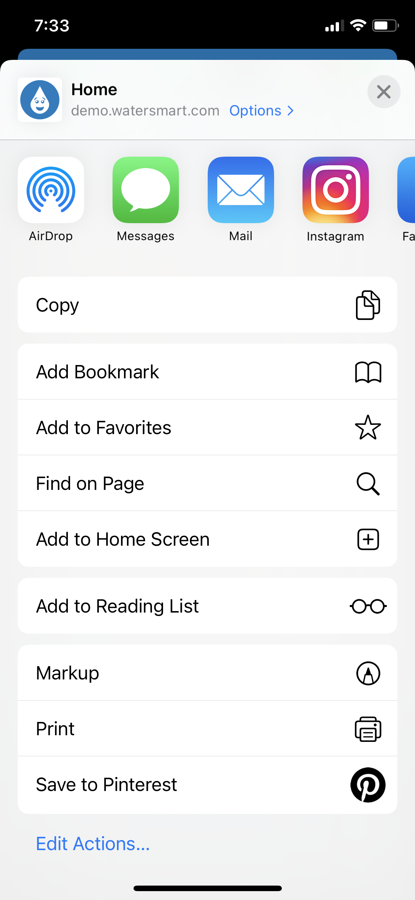
4. Edit the name to how you like it and tap “Add” in the top right of the screen. That’s it! | 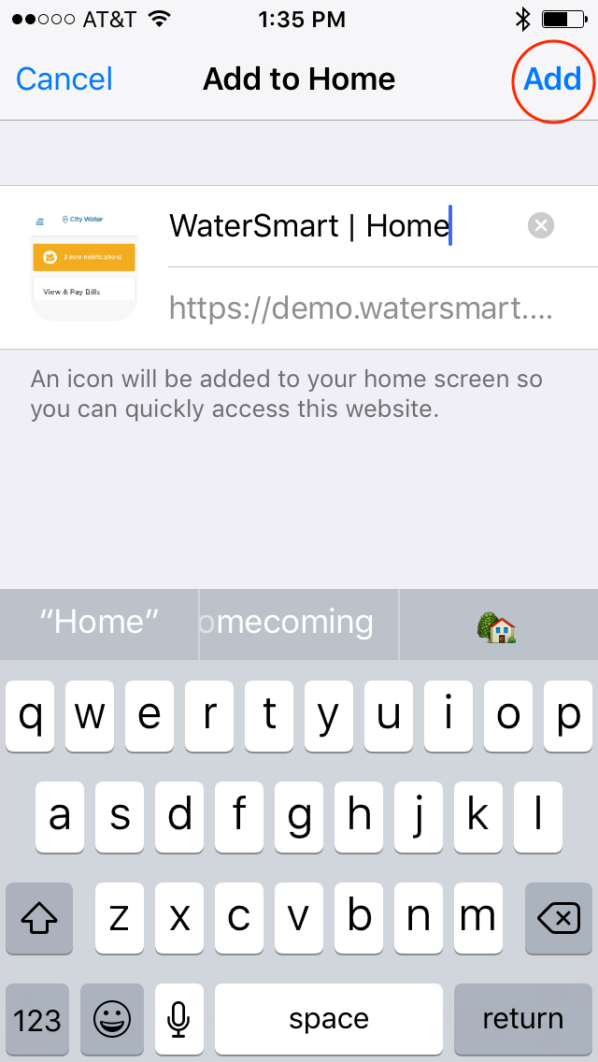
End result | 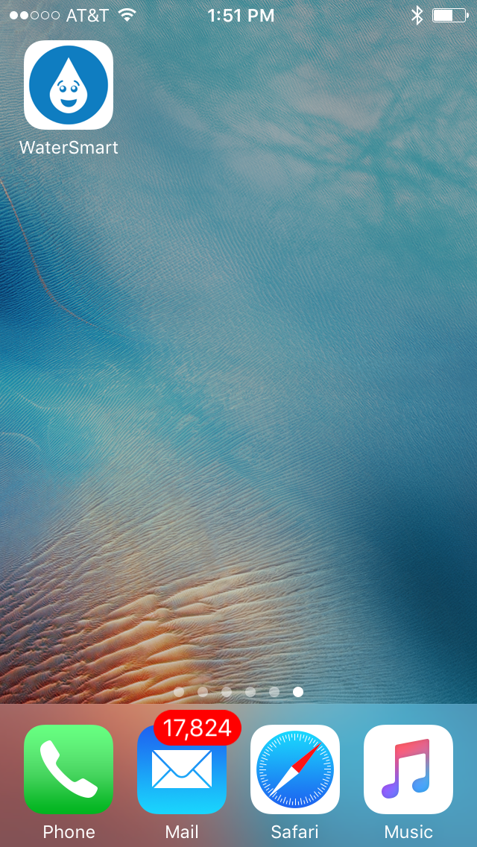

Android
Launch Chrome for Android and open the website or web page you want to pin to your home screen. Tap the menu button and tap Add to homescreen. You’ll be able to enter a name for the shortcut and then Chrome will add it to your home screen.
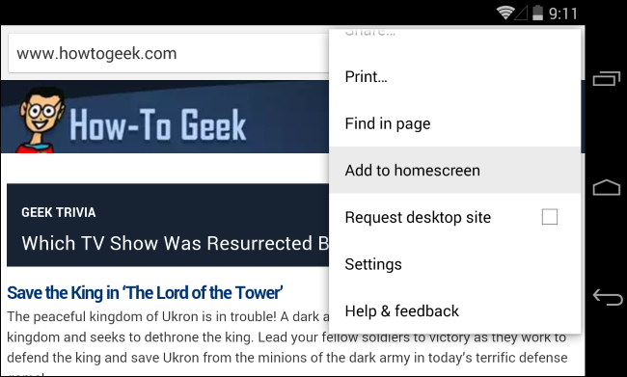
The icon will appear on your home screen like any other app shortcut or widget, so you can drag it around and put it wherever you like. Chrome for Android loads the website as a “web app” when you tap the icon, so it will get its own entry in the app switcher and won’t have any browser interface getting in the way.
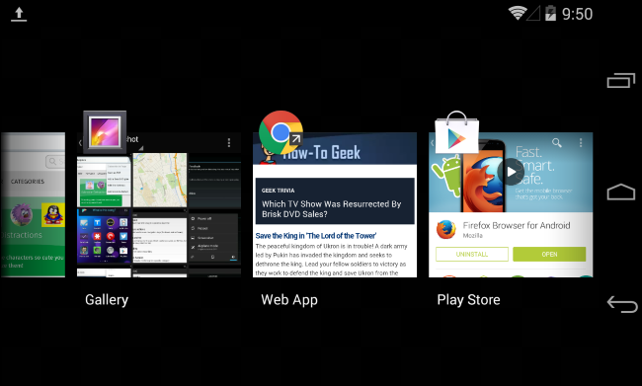
Other popular Android browsers also offer this feature. For example, Firefox for Android can do this if you tap the menu button, tap the Page option, and tap Add to Home Screen.
