Frequently Asked Questions – Water and Sanitation Rates

What do water and sanitation (wastewater) rates pay for?
Revenue collected from customers when they pay their water and sanitation bills is used to pay for a variety of expenses. By law, the amount collected cannot exceed the cost of providing the service because the District does not “profit”. Revenues pay for the purchase of water, imported and treated by Metropolitan Water District of Southern California (MWD), for electricity to run pumps and other equipment, chemicals such as sodium hydroxide (chlorine), for skilled labor (licensed treatment and distribution operators, engineers, and administrators), infrastructure maintenance and improvements to the water and wastewater systems. Revenues are also used to pay for conservation programs and initiatives like the Pure Water Project Las Virgenes – Triunfo, which will provide a new, reliable and sustainable source of water to our service area (visit www.ourpureh2o.com).
What will rates look like for the next 5 years?
Rates are scheduled to increase over the course of the next five years. Due to the COVID-19 pandemic, the District has recognized that many customers may be experiencing a financial hardship due to a loss or reduction in income. Therefore, the District is striving to keep rates as low as possible. The increase will depend on the amount of water a customer uses and how many residents reside in the household. A residential customer that uses the average amount of 25 HCF (hundred cubic feet) of water monthly will see their water bill increase from $121.27 to $132.63 in the first year starting March 1, 2021. A residential customer with three occupants will see their monthly sanitation bill increase from $53.35 to $55.36. Commercial customers that use an average of about 100 HCF, will see their monthly water bills increase from about $362.27 to $401.68 in the first year starting March 1, 2021. Commercial sanitation bills will increase by roughly 3.75 percent. Customers that use recycled water for irrigation purposes, will see their bills increase as well. A calculator is available at www.LVMWD.com/2020RateStudy, which allows individual customers to enter their specific information to determine the impact on their water and sanitation bill.
Why is the District adjusting rates?
The District needs to collect enough revenues from water and sanitation services in order to cover anticipated costs. Costs for operating and maintaining the water and sanitation systems is increasing. This is due to normal inflation, such as the increasing costs for electricity and chemicals, material costs, and labor costs. On average, inflation in the Los Angeles region has been about 2 to 3-1/2 percent per year. Revenues need to keep up with inflation, otherwise we will not be able to properly maintain and operate these vital systems. Rates are also increasing to pay for deferred maintenance and capital improvements, to ensure that we comply with new regulatory mandates imposed by the State or Federal government, and other challenges such as hardening facilities in response to increasing probabilities of wildfires. For instance, there are an increasing number of old pipelines that have been failing throughout the District and need to be replaced due to their age and deteriorating condition. The District also needs to increase revenues in order to build the Pure Water Project Las Virgenes-Triunfo. (visit www.ourpureh2o.com). This is a major project being undertaken by the District in partnership with the Triunfo Water and Sanitation District. This project was initially triggered for regulatory/environmental purposes but will also provide a new, reliable and sustainable source of water to our service area. Also, in order to be eligible for low-interest loans or bonds to pay for infrastructure improvements, the District needs to have a favorable bond rating. This can only be achieved if our projected revenues match projected costs and adequate reserves or “rainy-day” funds are available.
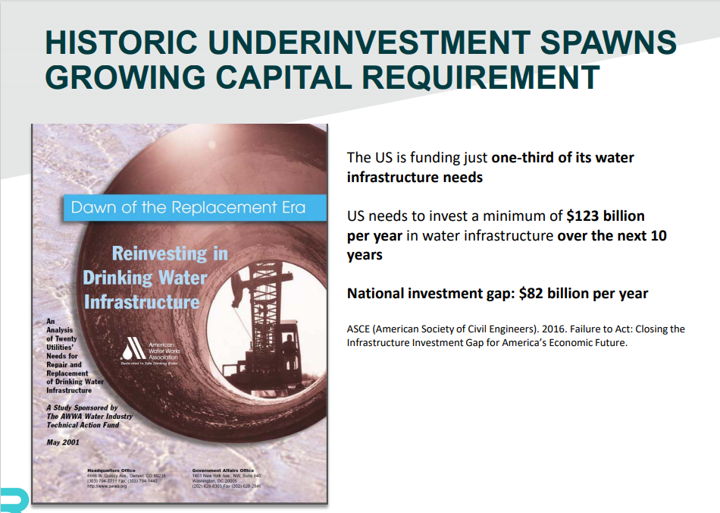
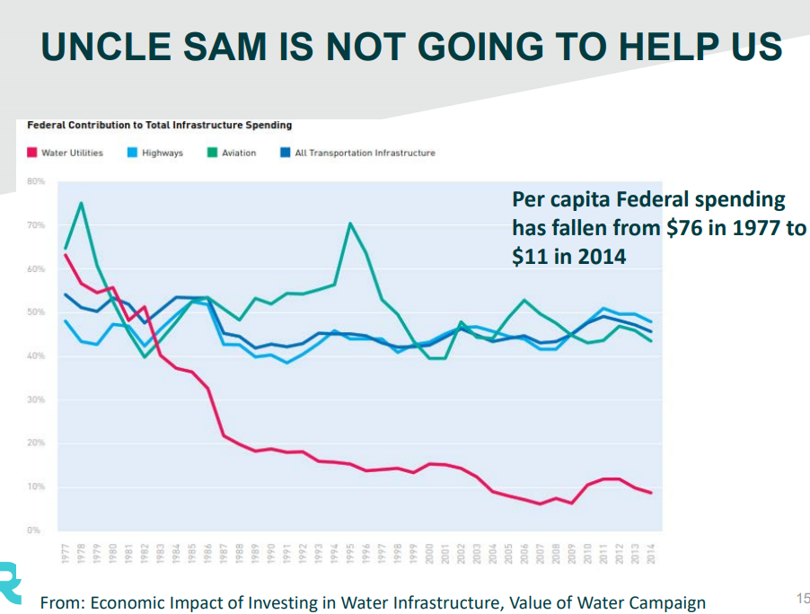

Can’t LVMWD postpone any rate increases?
Postponing rate increases is not considered good practice as it eventually leads to more substantial increases in the future. This has been a fairly common practice with many other water utilities. Pushing off rate increases to future years only leads to even bigger annual increases. LVMWD strives to minimize “spikes” in rate increases and takes a “slow and steady” approach when it comes to rate increases.

Can’t LVMWD tap into “reserve funds” in order to reduce rate increases?
LVMWD carries “reserve funds” that serve several purposes. In order to qualify for low interest rate loans or bonds that are used to pay for large capital improvement projects, a certain level of funds need to be readily available based on the District’s overall annual operational costs. Depleting these reserve funds will not only lower the District’s bond rating and ability to qualify for the lowest interest loans possible, but also puts the District at financial risk if there were a large disaster such as an earthquake and the District was unable to collect bills due from customers and/or to pay for repairing extensive damage to the water and sanitation systems. Reserve funds are also used to pay for capital improvement projects. Tapping into these funds to pay for on-going operational costs is not considered good industry practice as it would eventually lead to spikes in rate increases down the road.

How do LVMWD rates compare to other agencies that provide similar services?
The average LVMWD residential customer currently pays about $120 per month for their drinking water and $53 per month for sanitation service. These rates are very competitive compared to other communities in the region (visit www.lvmwd.com/for-customers/rates-and-fees/rate-comparison). Most other communities are also planning to increase rates for similar reasons and the District anticipates that we will continue to be competitive despite the proposed rate increases (see below). The average amount of residential water use is about 25 HCF (hundred cubic feet) per month. This is equivalent to 18,700 gallons of water. The cost per gallon of high quality drinking water delivered to your home amounts to less than one penny a gallon, even after the proposed rate increases. Compare this to purchasing a gallon of bottled water from the store that will cost in excess of $ 1 per gallon.
What is the District doing to control costs?
The District takes pride in finding ways and is always up for the challenge to reduce costs and keep rates as low as possible. Here is a small handful of some of actions we have taken and/or continue to take to achieve this objective:
- Seek out grants and/or low-interest loans to help pay for projects and programs.
- Recently completed expansion of the solar array on Las Virgenes Road from 1 megawatt to 5 megawatts, which will save the District over $10 million in the next 25 years.
- Completed improvements in 2019 to the Tapia Water Reclamation Facility that reduced annual electricity usage by 1.25 megawatt-hours and saving the District over $250,000 a year.
- We solicit competitive bids for materials, equipment, services, and capital improvement projects and award to the lowest, qualified bidder.
- We lobby Sacramento and Washington DC to oppose proposed legislation that would increase costs to the District and support bills that would reduce costs.
- Our staff closely analyzes alternatives for projects and programs and selects the most long-term, cost-effective solutions.
- The District utilizes state-of-the-art software and has processes in place that improve efficiencies in the workplace to keep our labor force to a minimum.

Is the District controlling employee pay and benefits?
Employee pay and benefits make up about 38% of the total costs to run the water and sanitation systems. While this is a significant amount, operating and maintaining a water and sanitation system that covers 120 square miles is labor intensive. Highly trained and skilled labor is essential to provide water and sanitation services 24/7. The District strives to keep employee compensation competitive compared to other water purveyors in the region. In 2017, the District completed a total compensation study and adjusted salaries to be between the median and 75th percentile in order to be competitive in the marketplace. There is a balance though. Too low, we will not be able to recruit and retain qualified staff needed to operate and maintain these highly complex systems. Communities that have failed to provide competitive compensation often experience high turn-over and, as a result, efficiencies are lost and the water and sanitation systems become less reliable. This could lead to excessive main breaks, loss of water pressure, boil orders, sewage overflows and harm to the environment, fines, and could even compromise the safety of the public. Your safety and providing reliable services is our highest priority but we also recognize the cost for water and sanitation services should be competitive. The District negotiates competitive compensation for its employees through the collective bargaining process, which typically results in compensation that keeps up with the cost of living, is competitive compared to that of other agencies in the region, and helps to ensure a steady and reliable workforce.
What is the process for adjusting rates?
There are several key steps that must be taken in order to comply with the law and to ensure customers have an opportunity to weigh-in on proposed rate increases. The District must first determine what it needs to accomplish and the associated costs in the coming years (revenues needed). Once this objective is met, the District determines how the costs need to be divided between various customer classes. This is done for potable water, sanitation and recycled water enterprises and is based on the cost to deliver that service. The District is then required to provide an opportunity for customers to weigh-in and provide comments. At least 45 days’ notice must be given to the public for providing input. The Board then takes public comments into consideration, may choose to make modifications to rates or rate structures, and then adopts the new rates. The process follows Proposition 218 requirements to ensure transparency and to make sure individual customers are only paying for the services they receive (not their neighbors). The illustrations below further describe the rate setting process.
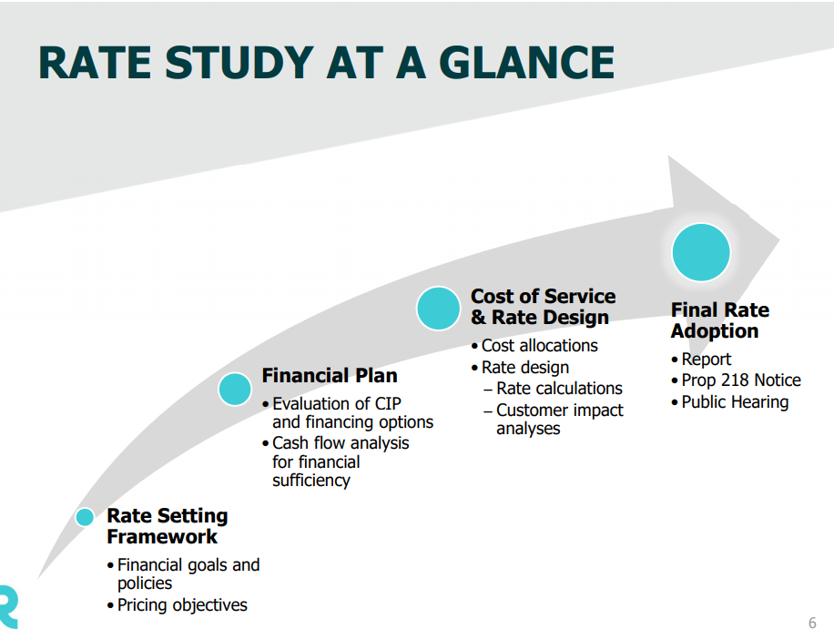
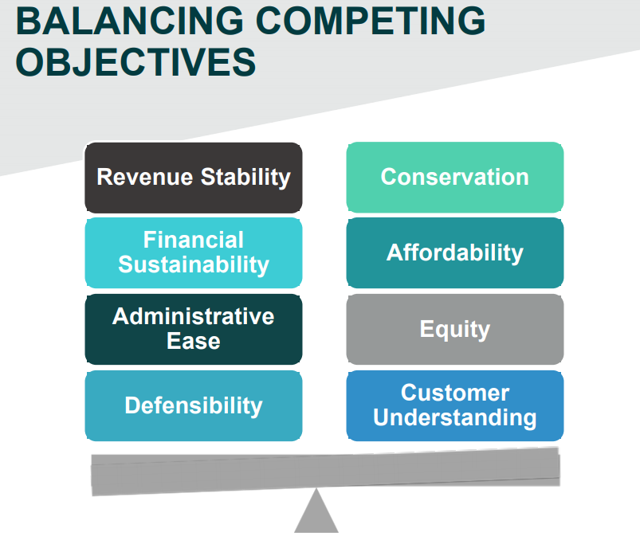

How can I keep my water and/or sanitation bill lower despite rate increases?
First and foremost, customers can use water as efficiently as possible and reduce or eliminate waste. Residential customers are given a customized water budget each month. Exceeding the budget results in higher water costs. Customers can stay within budget by using water as efficiently as possible and also ensuring that the budgets they receive are accurate. Water budgets are based on the square footage of irrigated outdoor landscapes, the number of occupants that reside in the household and other factors such as whether or not a residence has livestock such as horses. Residents can request an additional budget for a given month in order to fill a swimming pool.
There is a surprising number of customers that routinely exceed their budgets, some by a significant amount. The primary culprit is overwatering outdoor landscapes. In order to minimize the use of water for outdoor irrigation, customers can take advantage of our Weather Based Irrigation Controller System program and have a controller installed at a substantially reduced price. Customers may also want to consider redoing their landscapes and use climate appropriate plants that don’t require as much water. For more information about climate appropriate and sustainable landscapes and other water saving tips, visit Efficient Outdoor Water Use | Las Virgenes Municipal Water District (lvmwd.com).
More information on water budgets is located at Water Budgets | Las Virgenes Municipal Water District (lvmwd.com). Customers can also contact the District at 818-251-2100 and request a water survey in order to ensure that their water budget is accurate and that water is not being wasted through leaks in plumbing systems.
Why should I pay more so that my neighbor can have a lush green lawn all year round?
You won’t pay more. Proposition 218 prohibits shifting costs for providing service from one customer to another. The cost-of-service study looks closely at this issue to ensure that each individual customer only pays their fair share.
Where can I go to express my opinion and provide comments on the District’s water and sanitation rates?
If you have any questions or comments regarding LVMWD’s proposed rate adjustments, you can send an e-mail to generalmanager@lvmwd.com or telephone (818) 251-2200 to talk to a representative. The District is also hosting two separate virtual community meetings via Zoom on January 13 at 5:00 PM and January 21 at 7:00 PM. Customers can also express their opinion at the official Board Hearing scheduled on February 2, 2021 at 9:00 A.M. Detailed instructions for attending these meetings can be found on the Proposition 218 Notice and at www.LVMWD.com/2020RateStudy.
If you wish to protest the proposed rates, send us a letter by mail (or drop off at the District Headquarters) to General Manager or Clerk of the Board at 4232 Las Virgenes Road, Calabasas, CA 91302. Only letters that are mailed or dropped off at our headquarters prior to the close of the Hearing will be considered towards the Proposition 218 vote. Letters should include the address of the property along with the printed name of the property owner or tenant and signature.

